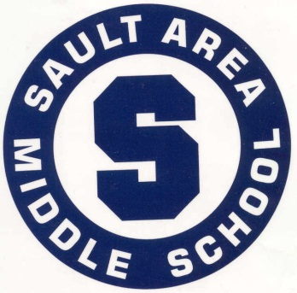

[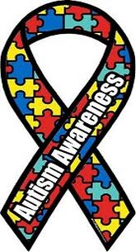](http://www.google.com/imgres?imgurl=http://www.literaryduckblog.org/wp-content/uploads/2011/04/autism_awareness_logo.jpg&imgrefurl=http://www.literaryduckblog.org/2011/04/celebrating-national-autism-awareness-month/&h=553&w=300&sz=46&tbnid=mxVQnIIYIrpqKM:&tbnh=90&tbnw=49&zoom=1&docid=-EyGy-CIAoWdiM&hl=en&sa=X&ei=4W8MT8qFFI7FsQKuqbCNBg&sqi=2&ved=0CKMBEPUBMAM&dur=672)

Peer to Peer

Support Program

Contact Information:

# Partners in Supporting KIDS!

**School Name Here**

#### School Name Here

School Name Here

Phone: (269)



# What to expect:

**Mentors (LINKS/Peers) will be matched with a student with Autism Spectrum Disorder (ASD) or other disability and asked to model socialization and independence skills. We are not asking kids to stop being kids or stop spending time with their peer group, we are asking them to include their student in social situations. Their commitment is exclusive to the school day and that specific class and/or lunch time. Peer mentors will have the opportunity to meet with the facilitator on a monthly basis to evaluate the program and have any questions or concerns answered.**

***“Students with adequate social skills are more likely to have positive outcomes, while significant social difficulties place the child at risk for developing later problem behaviors (Koegel, Koegel, & Surrat, 1992) and interfere with the development of peer relationships.”***

# Purpose:

**The peer to peer support program provides many opportunities for general education students, as well as the students with Autism Spectrum Disorder (ASD) and other disabilities. Students learn to relate to people with different needs and develop an increased understanding of individual differences. Student responsibility is also encouraged.**

#### Peer to Peer Support Program