Spoken language is transient. When we present information verbally, the words are available only for a brief moment. However, when we present information visually, it can be there for as long as the user needs it. This is particularly important for individuals with ASD, because they use vision as their primary modality. Visual supports - presenting directions or other information visually - clarify expectations, increase comprehension, and enhance a student's ability to understand, anticipate, and participate in the school and other settings.

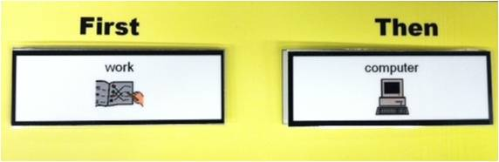

It is important to remember that we all use and benefit from visual supports - calendars, memos, notes, cookbooks - but those students with ASD and visual learners *need* visual supports. Once visual supports are in place, we don't eliminate them, even if a student doesn't appear to use them. *Visual supports need to be kept in place for the student's "worst" day.* We do, however, change visual supports, making them more portable and age-appropriate as our students get older. *It is much easier to change supports than to reintroduce the idea of operating from them.*

There are several kinds of visual supports, such as visual schedules, break cards, and first-then schedules, and they come in a variety of forms. Some use symbolic pictures, where others use photographs, and still others use only written words. The variables are dependent upon and should be designed based on the individual student's needs.

**Things to Remember**

* It is only by using the visuals that students will attach meaning to them.
* When teaching visuals, remember the sequence - students should follow a schedule by either going top to bottom or left to right.
* Sometimes you will see immediate results. Sometimes it takes days, weeks, or months before you see results. STICK WITH IT, but be thinking about the possibility of making modifications. Sometimes one little change can make a big difference.
* Some visual supports can be faded over time but it’s a good idea to keep them handy for those times when the student needs a little extra support because they aren’t feeling well, haven’t had enough sleep, or are just having an “off day.” If the supports are kept in place they can be easily changed when the student transitions to a new, more challenging environment.
* Make visual supports age appropriate. Consider the size and portability of the visual as well as the kind of visual symbols you used (e.g., objects, pictures, words).
* Take all school settings into consideration. Don’t forget recess, lunch, inclusion, etc. You can make visual supports portable and easy to access by keeping them in an envelope that hangs by the door. Teach students to get the envelope they’ll need to take with them to activities around the school.
* When using visual supports, pair them with spoken language so students begin to attach meaning. But use the words sparingly and match key words and phrases to the objects, pictures, or actions.
* The higher the stress level, the more need for visuals. Using spoken language usually serves to increase rather than decrease stress levels. Using pictures allows us to communicate effectively with the student without adding to their stress.
* Independence is our goal! Visual supports promote independence by providing visual cues which can eventually be used by the student for self-prompting. Verbal cues alone can create independence on other people.
* All behavior is communication!

**Resources**

[How Do I Use a Visual Schedule?](http://www.vbisd.org/cms/lib6/MI01000711/Centricity/Domain/40/How%20Do%20I%20Use%20a%20Visual%20Schedule.pdf)

1. A “check schedule” card brings the student to his/her schedule. The check schedule

card is kept right next to the schedule. When it is time for the student to transition to

the next activity, you remove the card, hand it to the student and say, and “check

your schedule.” The student knows the card belongs next to the schedule and the

need for order will “bring” the student over to where the schedule is.

A “check schedule” card may be a picture of the schedule, the student’s name, or any

other picture.

2. Once the student is at his/her schedule, he/she can be cued or physically assisted to

take the next card on the schedule. Note: Students who are familiar with the schedule

will likely do this independently.

3. The object/picture/word that the student pulls off of the schedule tells him/her

where he/she is going. A “receiver envelope” or other receiver object (e.g., cup,

basket) is kept at the site where the activity will occur. The student puts the picture

in the envelope and then he/she is right there where the activity takes place –

transition complete!

As a student progresses with the schedule, he/she may no longer need a schedule that

requires pulling and icon or object off the schedule and matching it to the activity area. For

example, some students can pull the icons and put them in an “all done” envelope at the

base of the schedule or follow a written schedule wherein they cross the items off as they go.

Schedules can be used for the school day, morning/evening routines at home, and for special occasions such as field trips and parties.

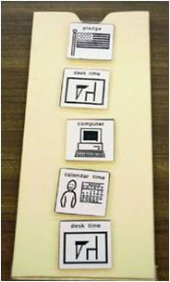 [Mini-Schedules](http://www.vbisd.org/cms/lib6/MI01000711/Centricity/Domain/40/Mini-Schedules.pdf)

Mini-schedules break down an activity

into manageable steps. They are a visual

form of task analysis.

Here is an example of a mini-schedule

for a student’s bathroom routine.

Examples of other routines that lend themselves

well to a mini-schedule:

\_ getting dressed for going outdoors

\_ washing dishes

\_ circle time activities

\_ assembly tasks

\_ cooking tasks

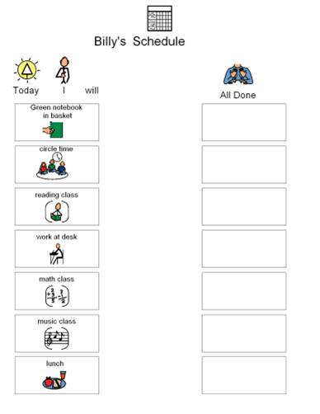

[Break Cards](http://www.vbisd.org/cms/lib6/MI01000711/Centricity/Domain/40/Break%20Cards.pdf)

Being able to identify the need for a break and being able to get a break appropriately are

important skills in the world of school and the world of work. The break card is an effective

way to teach a student to appropriately request a break.

Protocol for Teaching How to Take a Break:

1. When the student begins to show signs of irritation or agitation, hand the student a

break card and say, “It looks like you need a break.” This will help the

student identify that when he/she feels the way he/she does, that he/she should ask

for a break.

2. When the student takes the break card, immediately allow (or prompt) the student to

go to the break area.

3. Set the timer for 5 minutes (a visual timer may be most effective).

4. After the 5 minutes have passed, prompt the student to return to the activity.

Overtime, the student should be able to independently request a break through this pairing

process.

Note: The

[Wait Cards](http://www.vbisd.org/cms/lib6/MI01000711/Centricity/Domain/40/Wait%20Cards.pdf" \t "_blank)-

[First-Then Schedules](http://www.vbisd.org/cms/lib6/MI01000711/Centricity/Domain/40/First-Then%20Schedules.pdf)- 

Consider this familiar scene…

The teacher wants the student to complete assigned work.

The student wants to play a computer game.

A first-then schedule is a “contract” with the student that gives the student a visual reminder

that once a non-preferred task is complete, he/she will get to do his/her preferred activity.

For students that find a half-day or full-day schedule too overwhelming, a first-then schedule

can also be used to navigate the regular school day schedule (rather than just using it as a

contract for completing non-preferred activities).

**Useful Websites**

<http://www.setbc.org/pictureSET/Default.aspx>

<http://www.boardmakershare.com/Activities/Browse>

<http://mrsriley.com/>

<http://www.dotolearn.com>

<http://www.tinsnips.org>

<http://www.usevisualstrategies.com>

